Lecture – 1

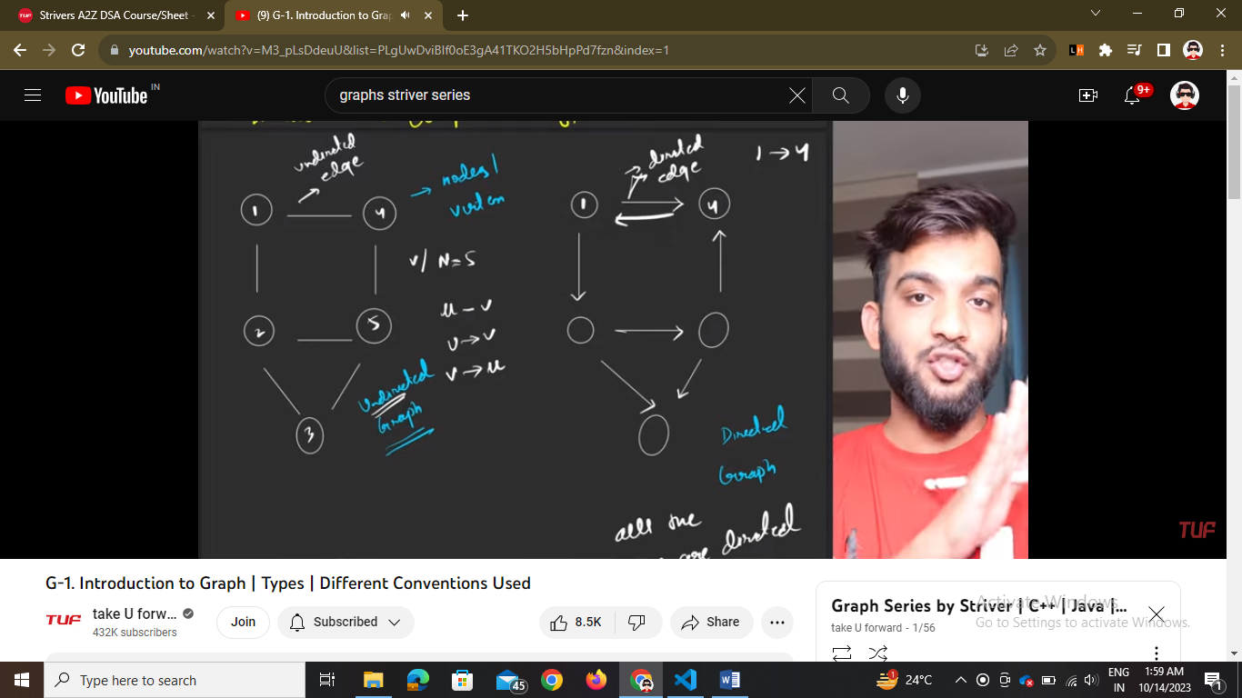

In directed all edges should be directed

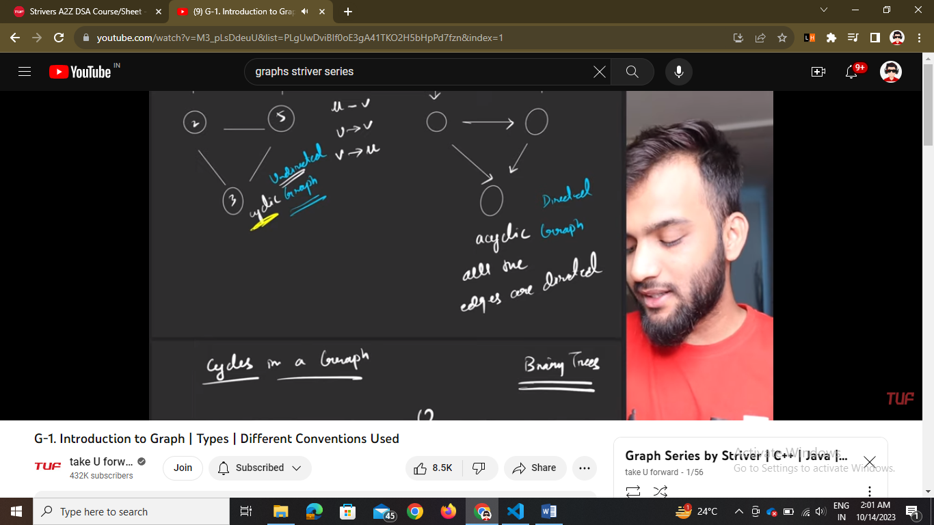

So all are graphs even it is not in circular or loop but if there is a cycle it is cyclic graph and otherwise acyclic graph

If we start from one node and end at that same node it is cycle

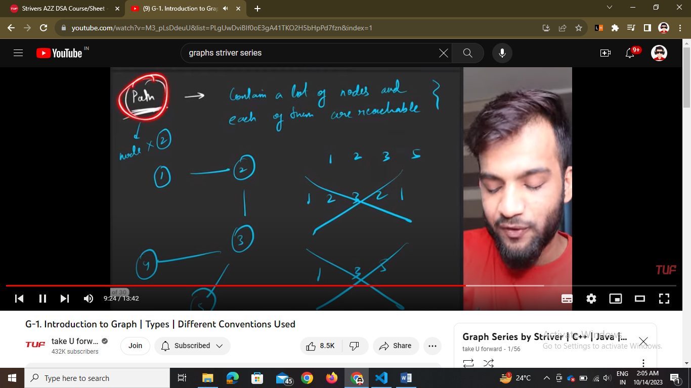

So in path no 2 same nodes can come and all nodes should have connectivity between them

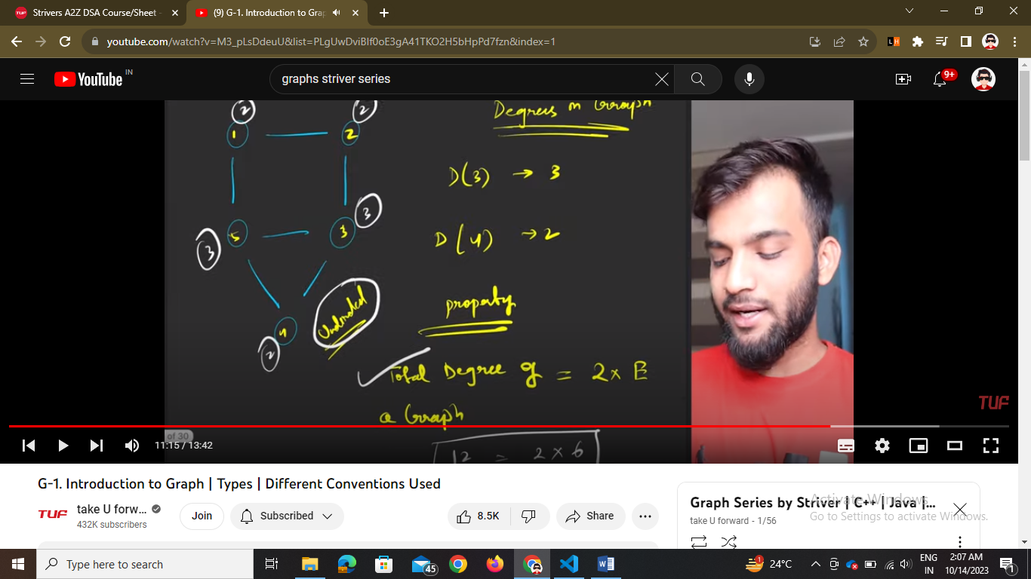

For undirected graphs the degree = no. of edges joined to that vertex

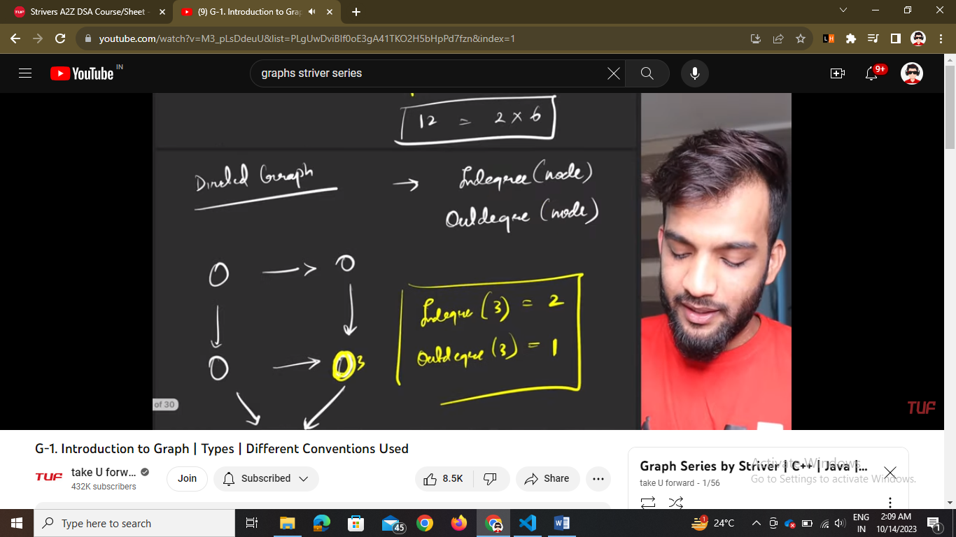

For directed graphs

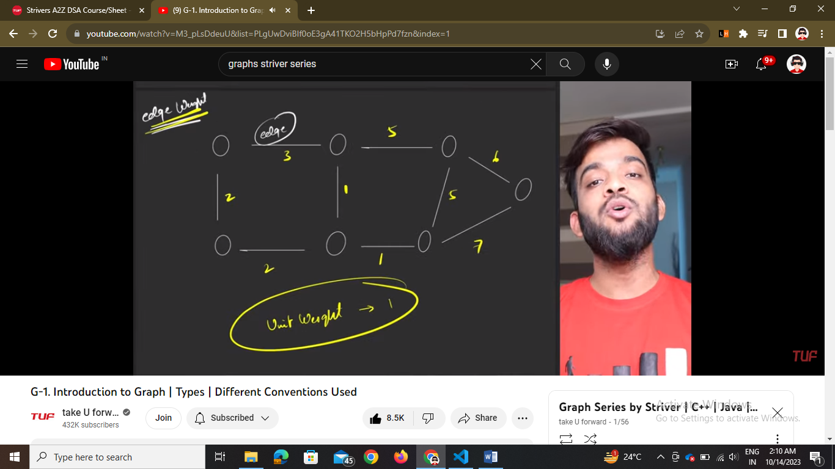

Lecture – 2

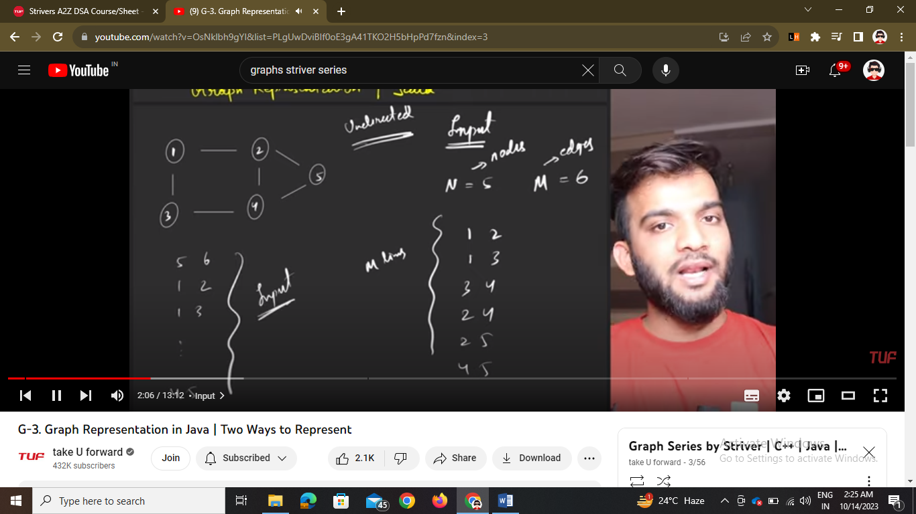

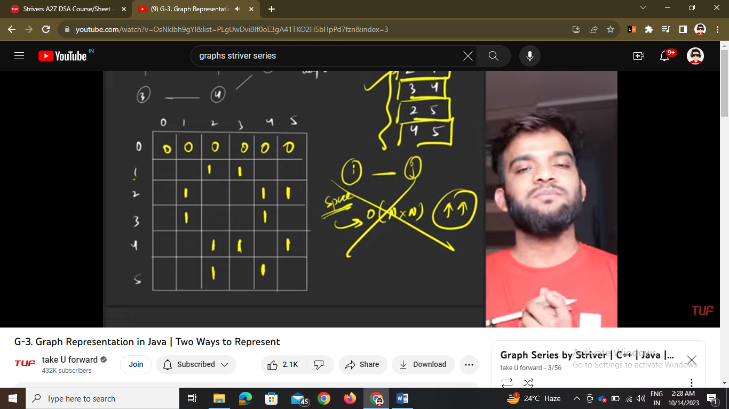

We have two options to store graphs – adjanjancy matrix or adjanajancy list

1. 1 based indexing means 1 to 5 is marked on graph and graph also has 5 nodes
2. Matrix size should be n+1 -🡪 this is for undirected graphs

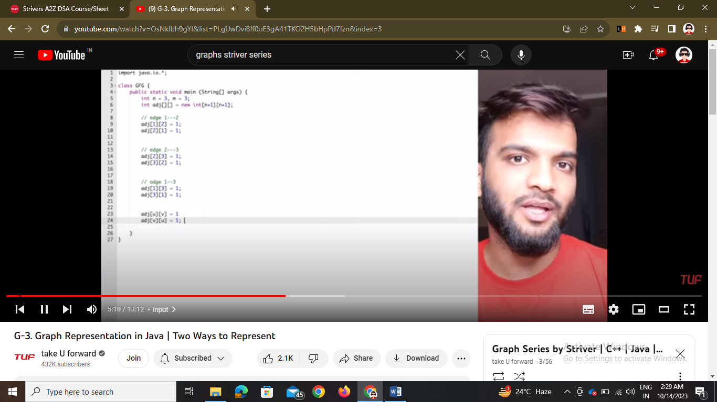

But this is not space optimized that is this martrix takes o(n2) space

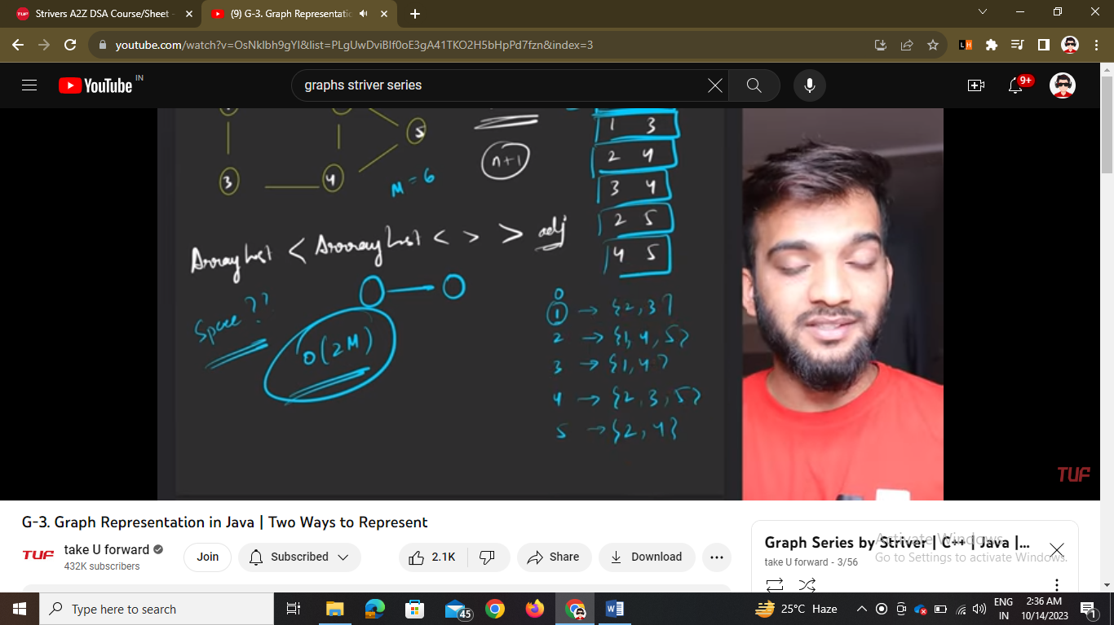

This is adjanjancy list

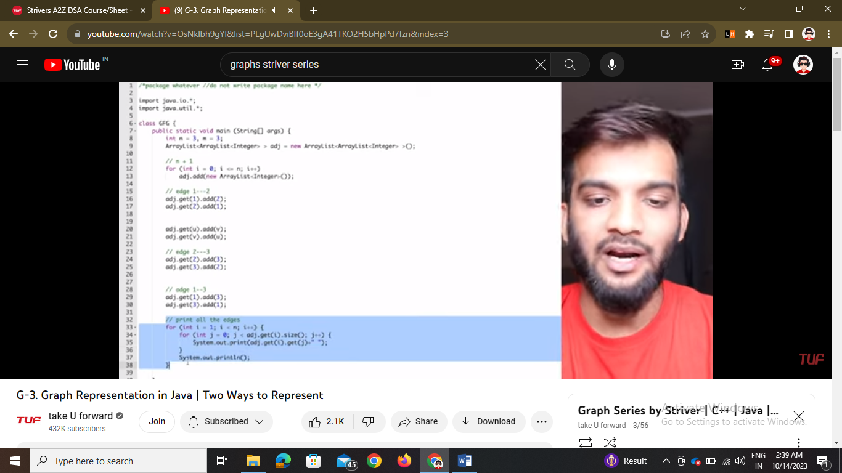

This is for undirected graph but if it becomes directed then remove the line 2 to 1 if the graph directs only from 1 to 2

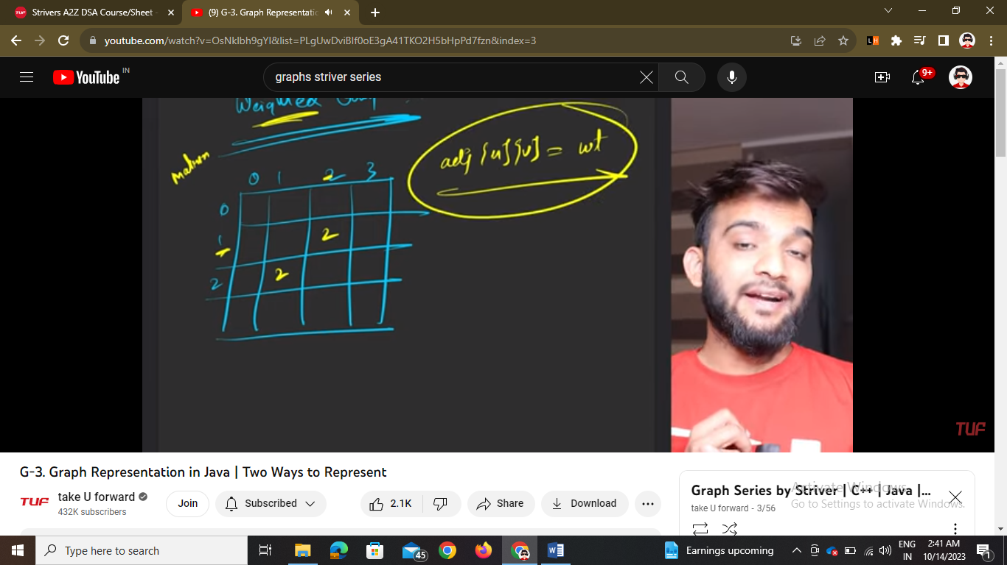

In case of a weighted graph in matrix

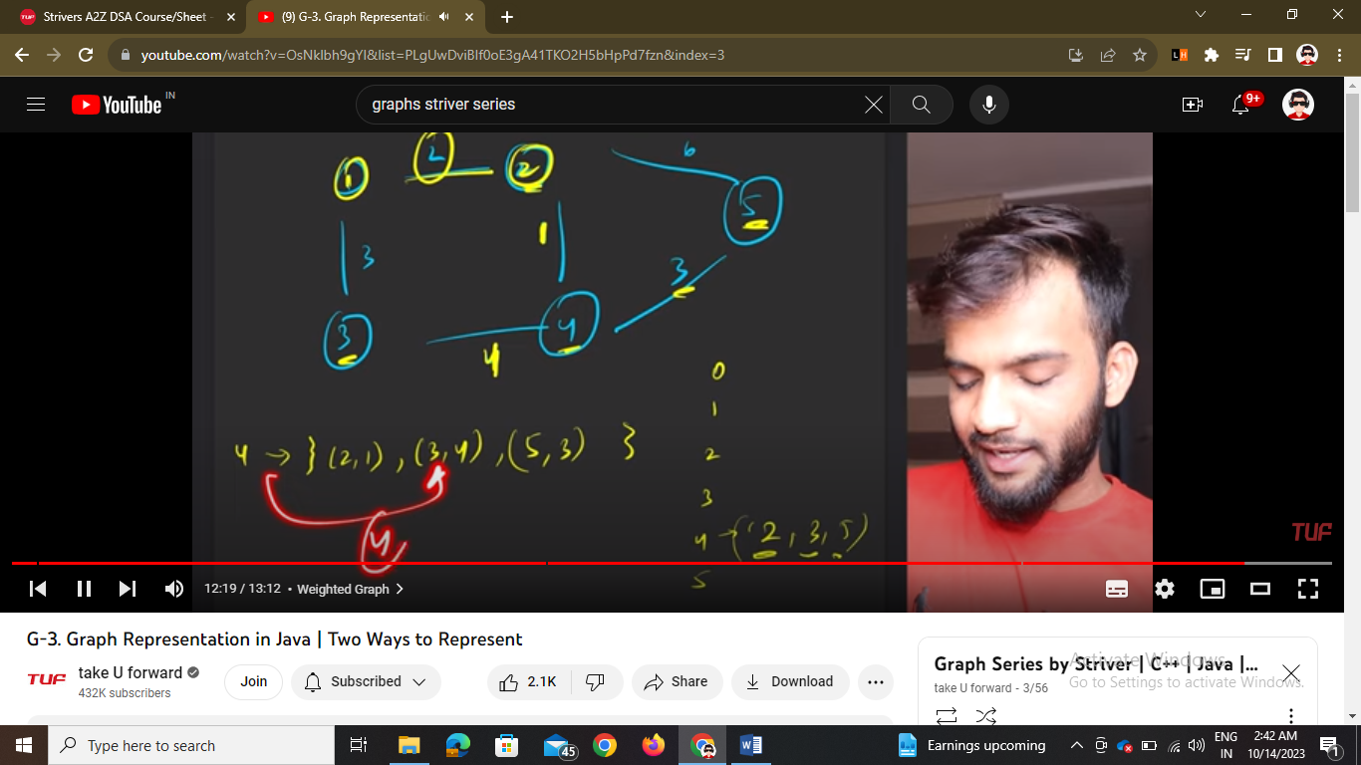

In case of list we have to make a pair of int, int and then store the adjacent element + weight of element

Lecture – 3

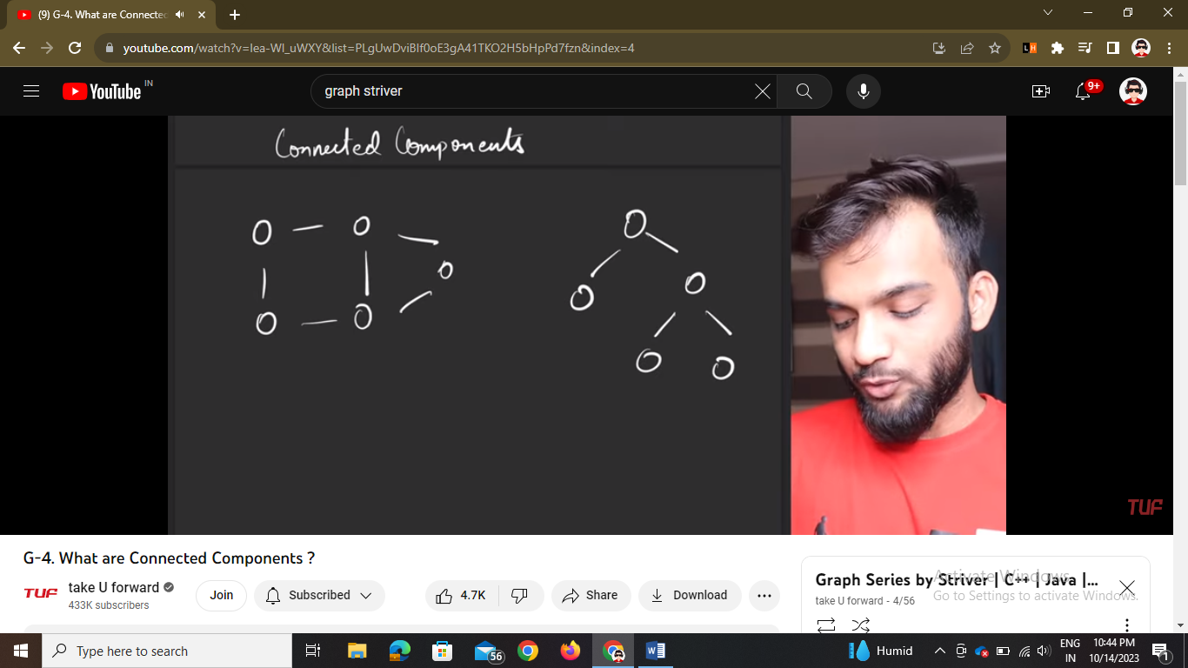

These both are graphs second one is binary tree also but graph also

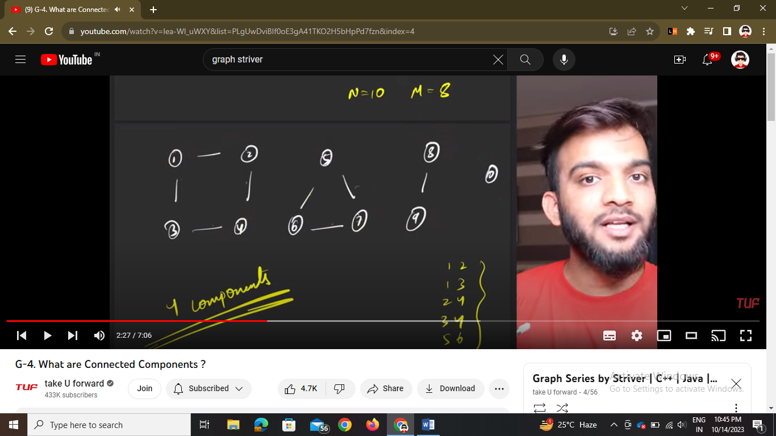

This whole is a graph also which has 4 components

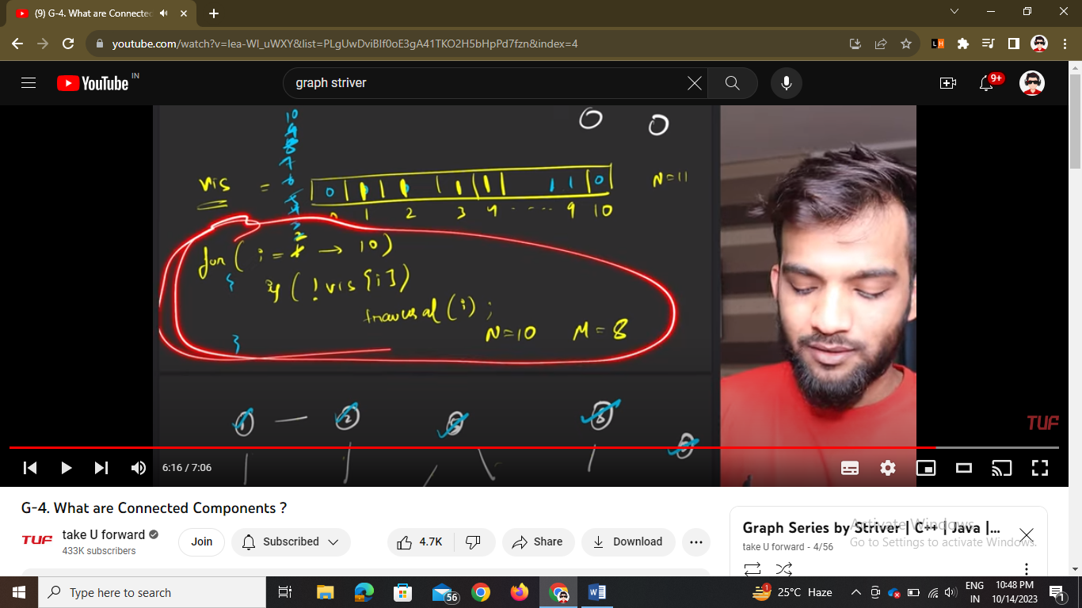

To calculate all components we have traversal algo -🡪 we will take the visited array and if we traverse the componenets we mark it as 1 in array and ++components

Lecture – 5

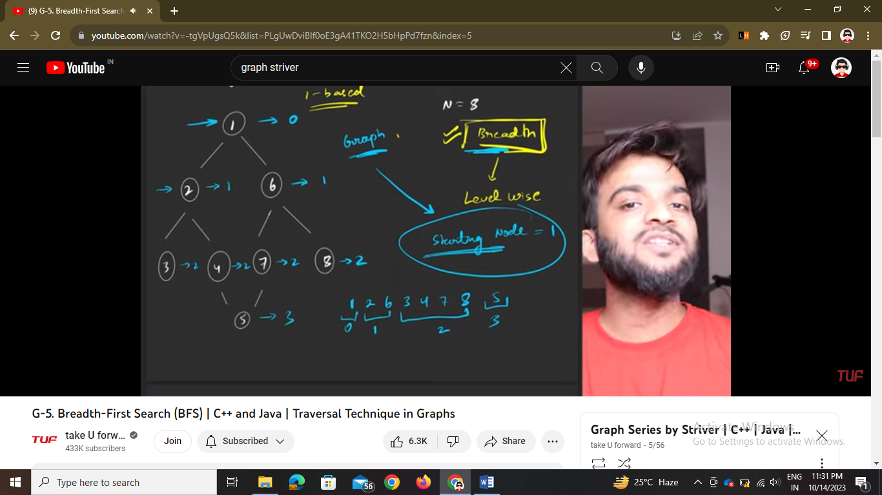

So there are 0 based and 1 based indexing that is the numbering in graph starts from 1 or 0. Also the bfs depends on the starting node here it is 1 .

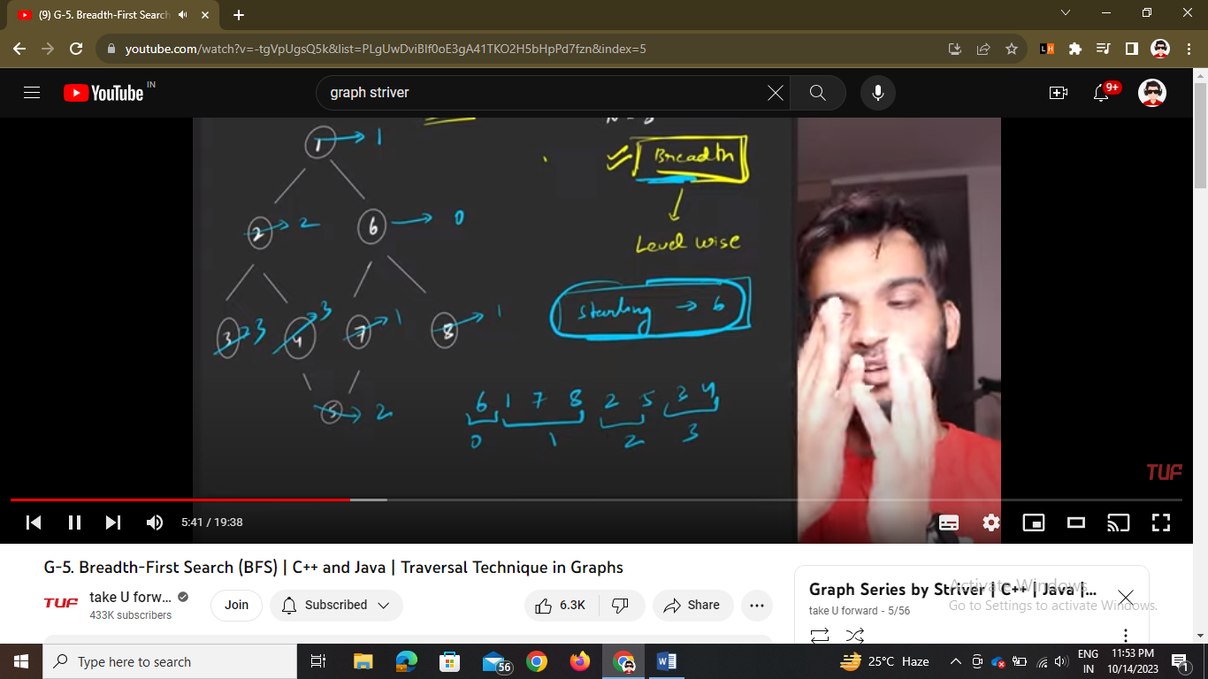

Here starting node is 6

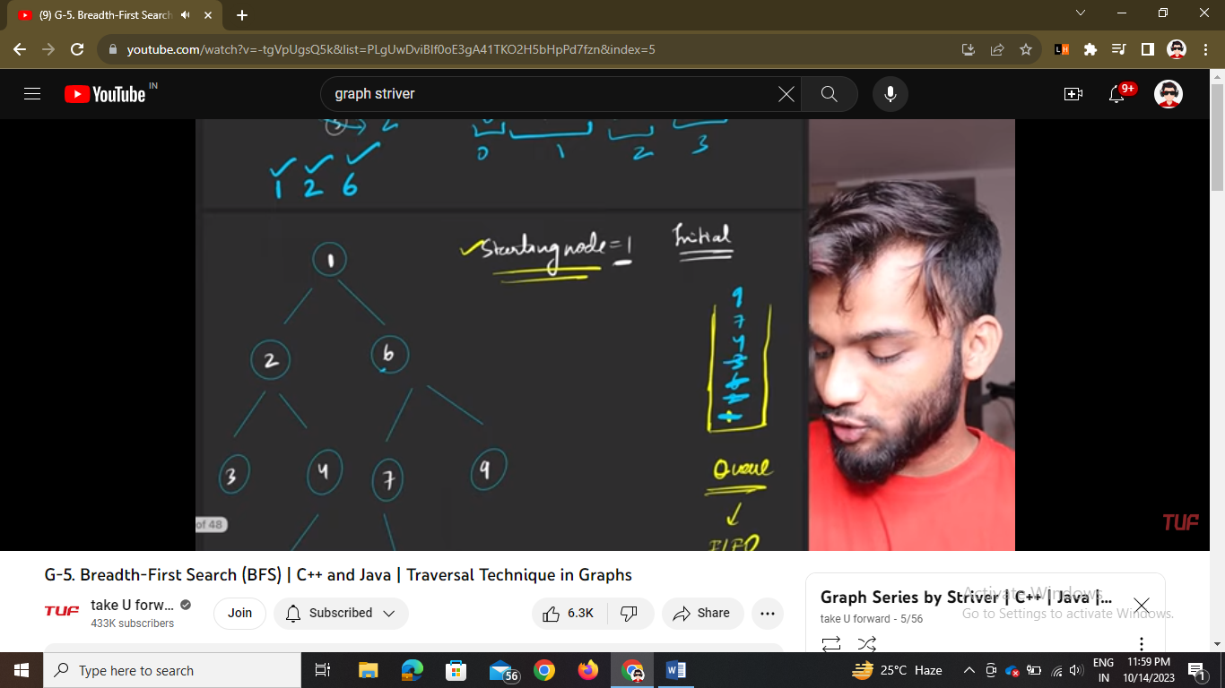

So take a queue and boolean visited array. Put 1 in queue and then pop out and push all children or adjacent elements in queue and add 1 in bfs array

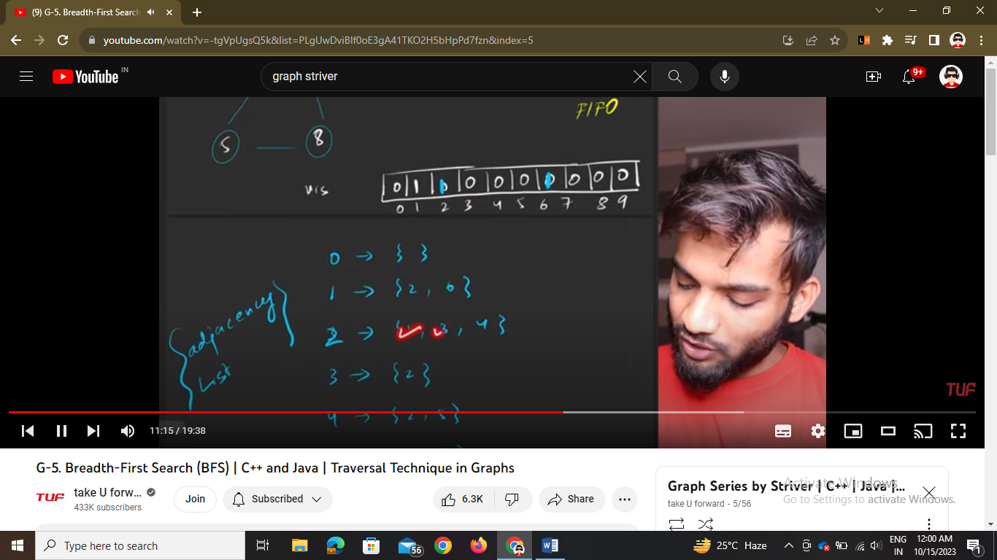

With the help of adjancy list we take care of neighbours of nodes

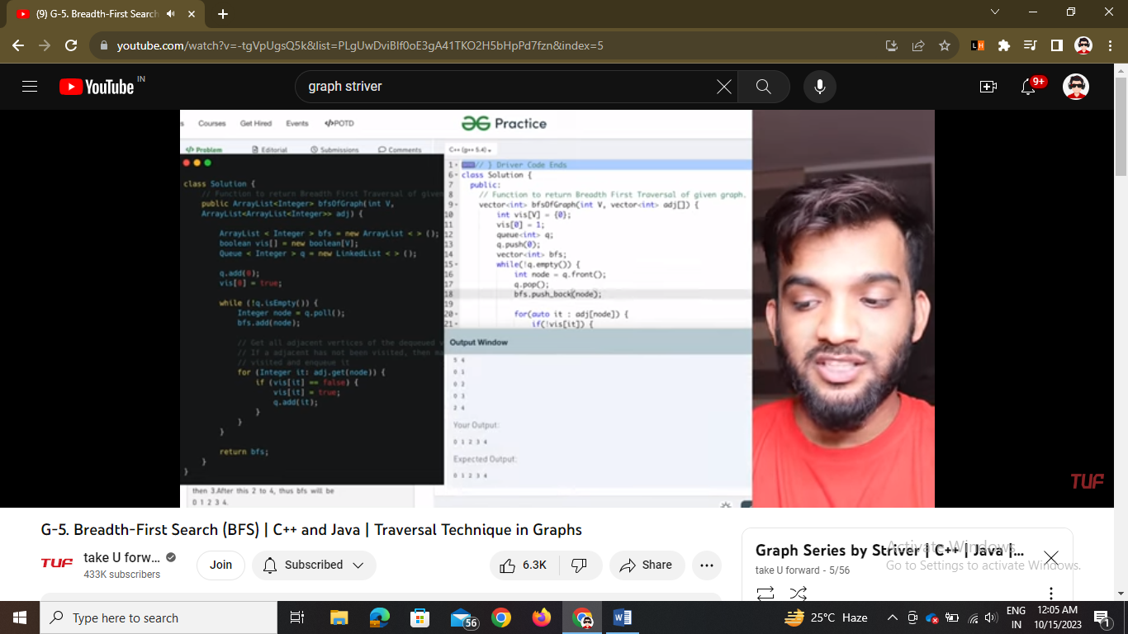

Code of java of bfs

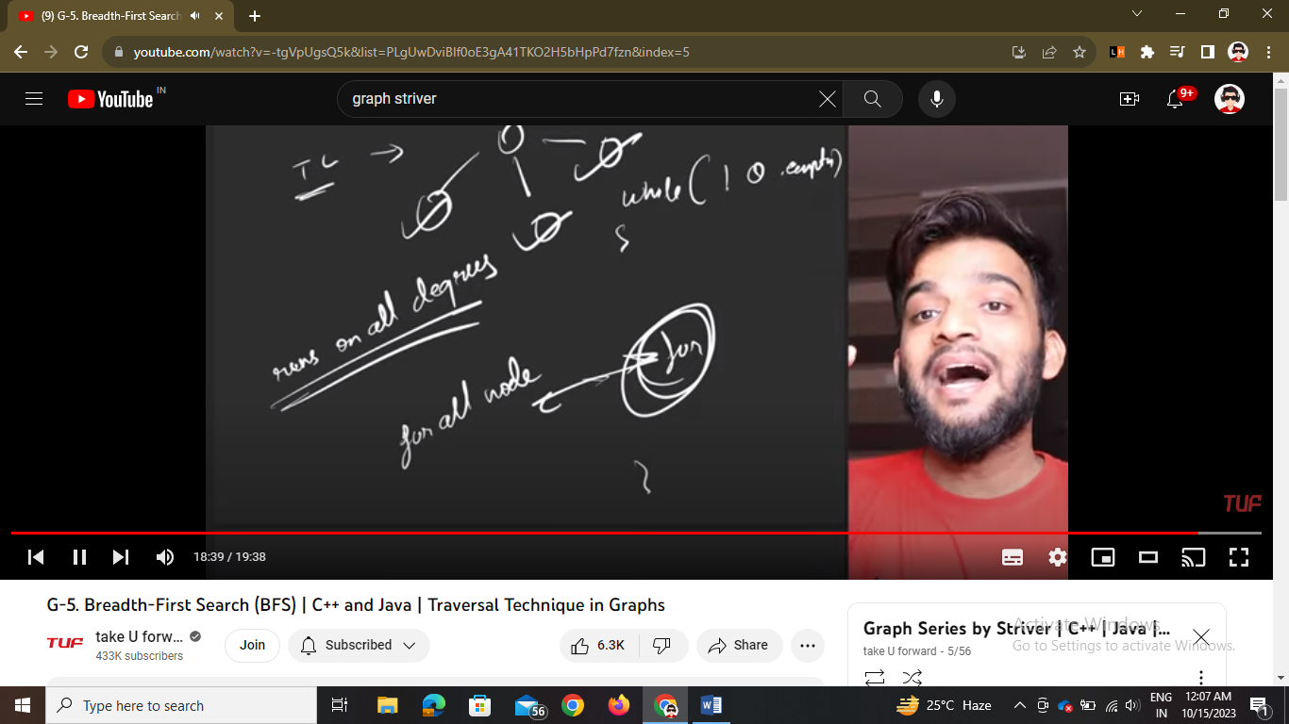

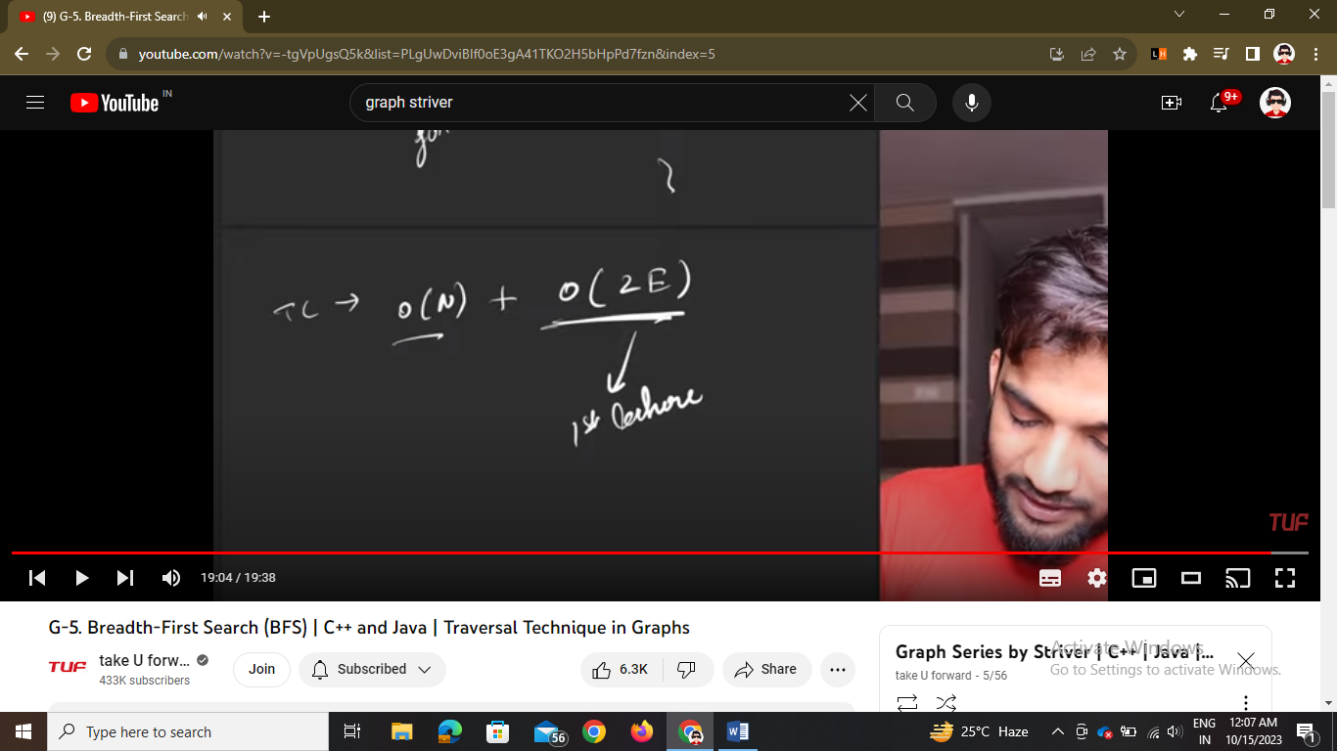

Time complexity is this as we traverse for all nodes and at each node we took all neighbor elements that is equal to degree of that node == 2 E

Lecture - 6

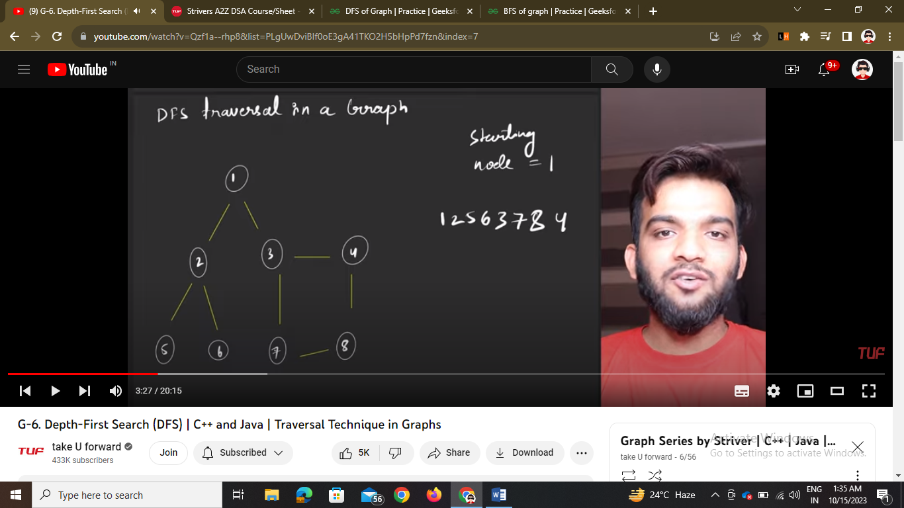

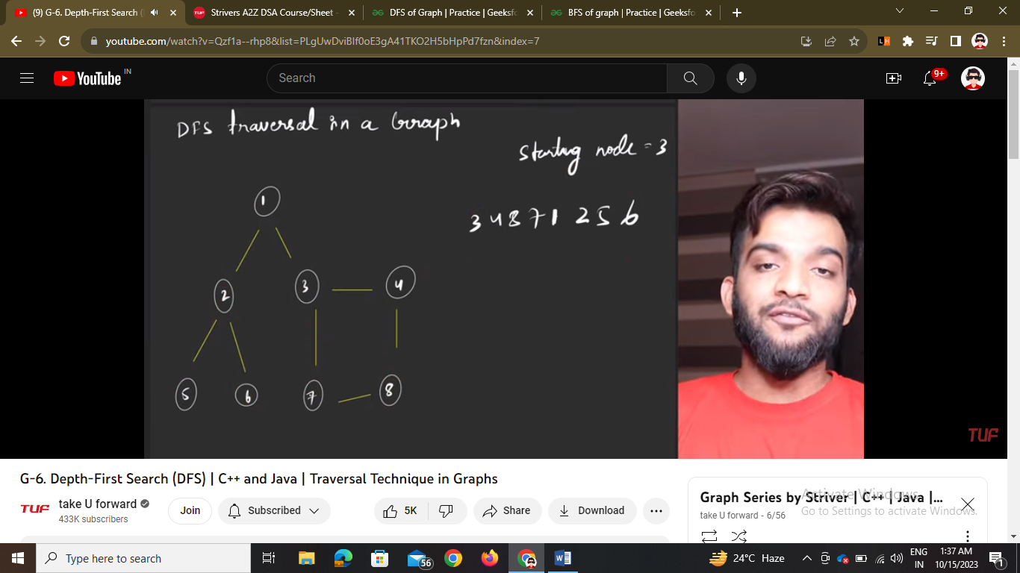

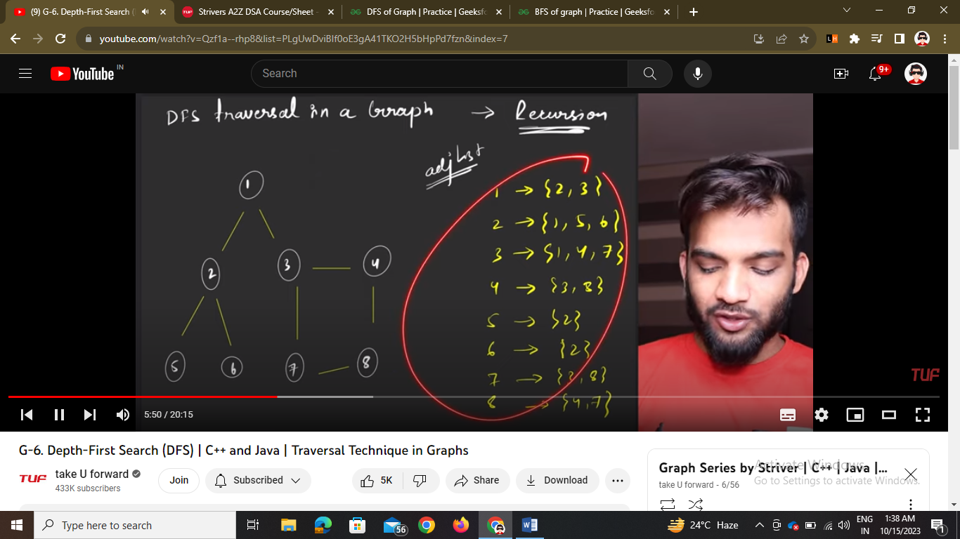

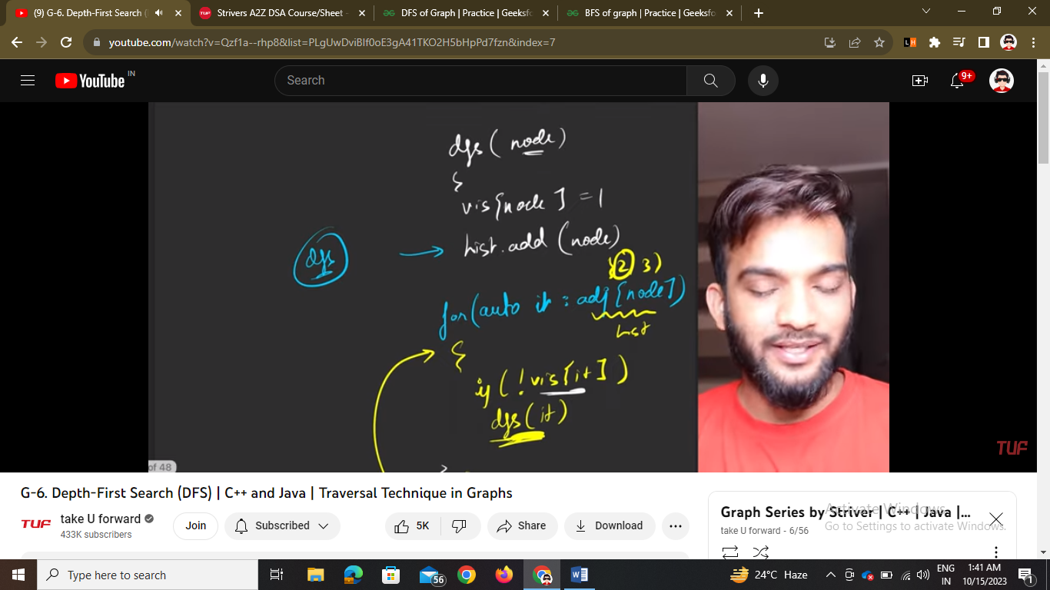

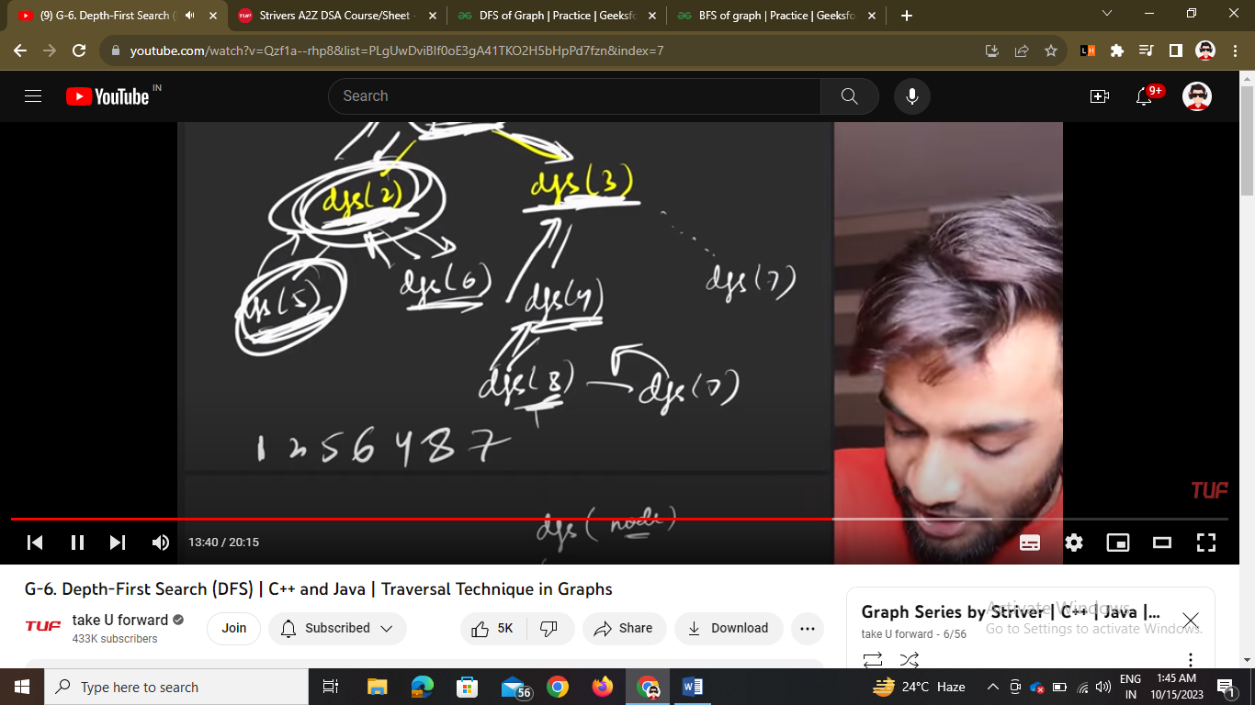

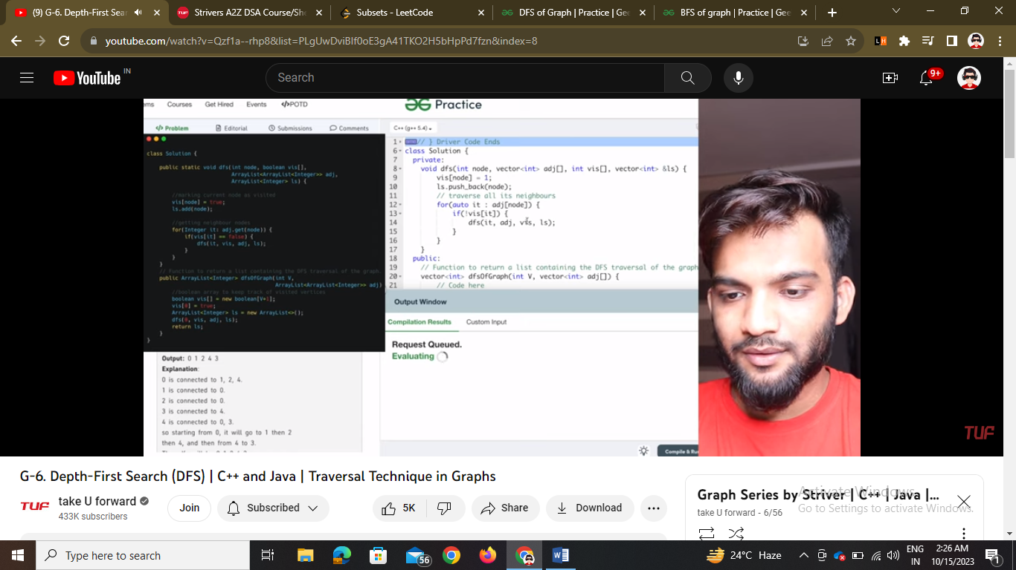

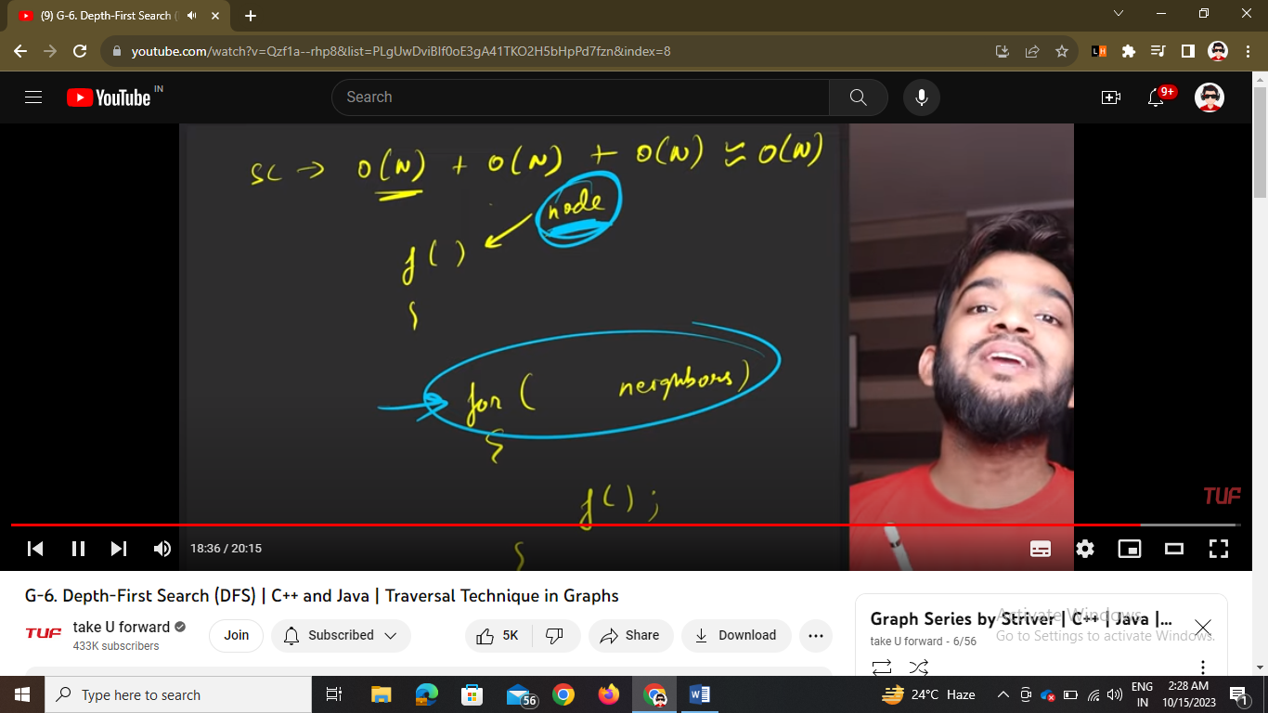

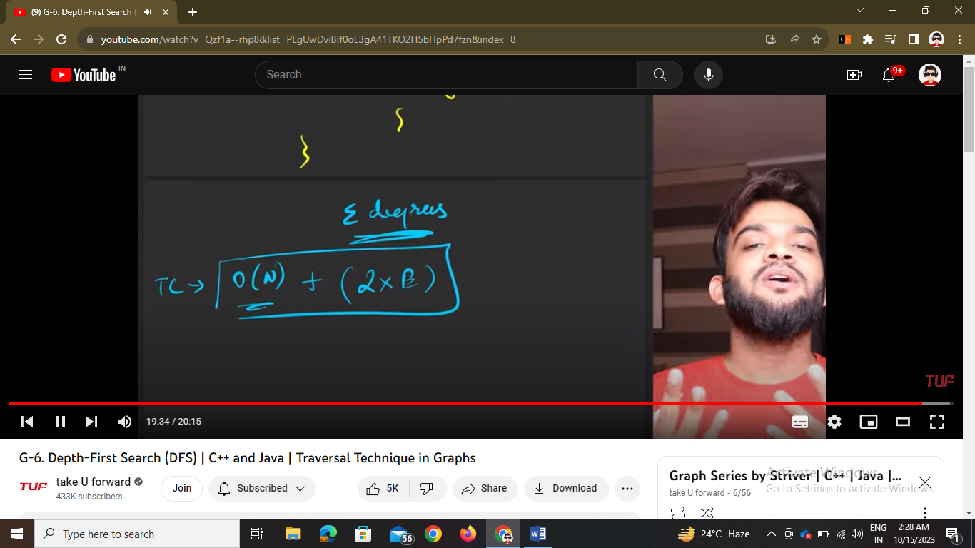

For undirected graphs